**SUMMARY**

Creating a “Smart Conveyor System” using Arduino is the main target of our project. This smart conveyor system is designed to enhance luggage handling at airports. Once the passenger keeps the luggage on the convey belt the luggage's mass is measured. Also, the dimensions of the luggage (length, breadth, and height) are measured. If the luggage meets the mass criteria and the dimension criteria then it is directed to one of the three aeroplanes (Plane A, Plane B, Plane C). On the other hand, if the mass exceeds the maximum mass and dimensions exceed the dimension criteria the system rejects the luggage, preventing any potential issues.

## **TABLE OF CONTENT**

**DECLARATION** 4

**SUMMARY** 5

**TABLE OF CONTENT** 6

**CHAPTER 01** 7

1.1 Introduction 7

1.2 Features of the Product 8

**CHAPTER 02** 9

2.1 Problem Identification 9

2.2 Research and Design 10

2.3 Building the Robot 11

2.4 Programming 12

**CHAPTER 03** 13

3.1 Results of the operation 13

**CHAPTER 04** 14

4.1 Limitations, Recommendations and Conclusion 14

**REFERENCES** 15

**APPENDIX** 16

# **CHAPTER 01**

## Introduction

Nowadays, efficient, and accurate baggage handling is crucial to ensuring a positive travel experience in modern airports. The aim of the "Smart Conveyor System" is to address the increasing demand for intelligent and automated systems in airports. This defines how the luggage is handled within airport terminals.

The "Smart Conveyor System" is the result of the intersection of robotics and airport infrastructure. It introduces luggage conveyor system equipped with advanced technologies. By the knowledge of robotics, the project provides a smart and efficient process for transporting passenger luggage from check-in to the relevant airplane.

Current conveyor belt systems used in airports may encounter challenges like efficiency, accuracy, and adaptability of the system. The Smart Conveyor system is designed to address the challenges faced by the current conveyor belts used in airports by setting a new benchmark for reliability in luggage handling. The project’s aim is to improve operational efficiency, optimize the entire luggage handling process, and minimize delays and errors.

The "Smart Conveyor System" seeks to elevate the standards of the services of airports and enhance the overall travel experience. So basically, this isn’t just a technological advancement but also a commitment of improving airport services.

## Features of the Product

Below are the features of our smart conveyor system.

* The conveyor belt only works when the luggage is kept on the belt.
* Measures the mass of the luggage and rejects the luggage that exceeds the mass criteria.
* Meanwhile, measures the dimensions of the luggage (length, breadth, and height) so that the luggage can be fixed according to the plane’s area.
* The accepted luggage is automatically directed to the desired plane.

# **CHAPTER 02**

## 2.1 Problem Identification

Some problems we identified are mentioned below.

1. Overweight Luggage

One of the major problems identified is the passengers often exceeding mass limits. Therefore, a suitable mass criterion is created for both hand luggage and checked luggage.

1. Oversized Luggage

The other problem identified is oversized luggage as that oversized luggage creates luggage handling issues when the luggage is boarding to the plane.

1. Manual Handling

Sometime human intervention is required to handle irregularities in luggage. Directing the luggage to the desired plane is done by humans. So, an automated system is required to direct the luggage to the desired aero plane.

## 2.2 Research and Design

When creating the smart conveyor system first the conveyor belts need to be created. So, we thought of using materials made from threads as it needs to travel along with wheels used in conveyor belts. To rotate the belt, we use small wheels or rollers. Then for measuring the mass of the luggage we use a load cell and to measure the dimensions of the luggage we use ultrasonic sensors. To convert the analog signals produced by the load cell to digital signals we use the HX-711 amplifier. We use green and red LEDs respectively to show whether the luggage is accepted or rejected. To display the desired flight, mass, and dimensions we use 3 LCDs. An IR sensor is used to detect the objects as the conveyor belt works only when the luggage is kept on the belt. Mini DC gear motors are used to move the belt of the conveyor belt. A battery pack is used to give power to the functioning of the mini-DC gear motors. We use push buttons to direct the luggage to the desired plane of the passenger. To control the speed and direction of the motor a motor driver is used.

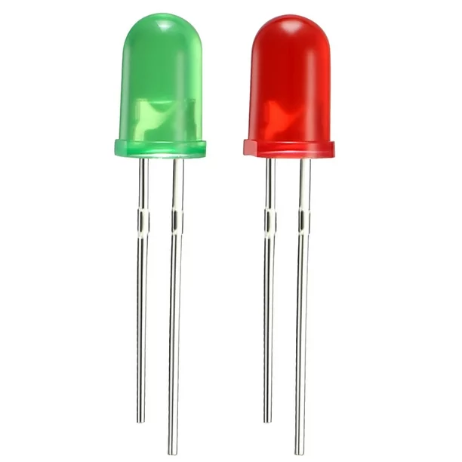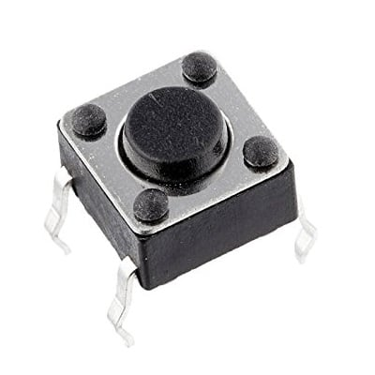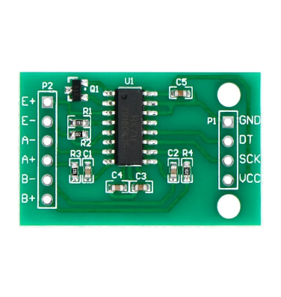IR sensor

## 2.3 Building the Robot

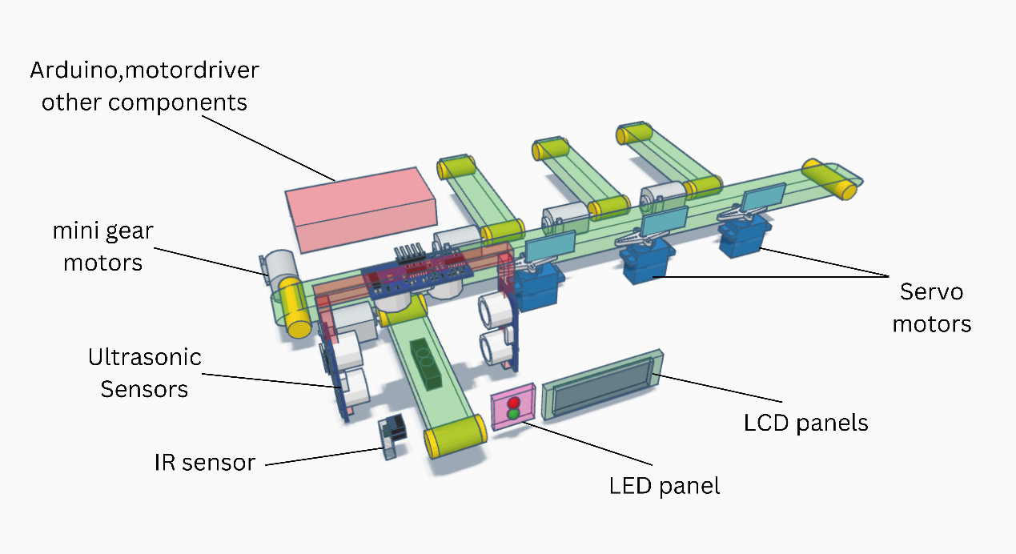

|  |  |
| --- | --- |
| Components | Quantity |
| Arduino board | 01 |
| Motor driver | 01 |
| Ultrasonic sensor | 03 |
| IR sensor | 01 |
| LED bulb | 02 |
| LCD display | 03 |
| Mini DC gear motor | 05 |
| Battery pack | 01 |
| Servo motors | 03 |
| Rubber thread | 01 |
| Wooden sheet | 01 |
| Regi foam | 01 |
| Jumper wires (x40) | 02 |
| Loadcell | 01 |
| HX711 amplifier | 01 |

The ‘Smart Conveyor System’ consist of 5 mini DC gear motors for each conveyor belt to rotate the belts. One mini DC gear motor will be connected to a motor driver, where it will help the DC motor to change the rotation direction and speed. The Ultrasonic sensors will go surrounding one Conveyor where the dimensions of the passing luggage will be measured through the sensors and in the same conveyor there will be a loadcell under the belt so the weight is measured of the objects. LCD’s are placed infront of the Conveyor system to read the results of the sensors. Push buttons are placed to direct the luggage to the desired aero plane. Servo motors are placed where the 3 conveyors are location which changed the location of the object towards the desired aero plane’s conveyor belt.

## 2.4 Programming

## First the passenger keeps one of the luggage on the conveyor belt. Once the luggage is kept the IR sensor will read the motion of the luggage so that the belt starts to move to the load cell.

## The load cell measures the mass of the luggage meanwhile the ultra-sonic sensors measure the dimensions of the luggage. The luggage will be rejected if it exceeds the mass and dimension criteria. The logic for the mass criteria would be as follows,

IF(mass <= 35kg)

{ Display mass

High the green LED

Pass to desired plane

## }

ELSE IF

{ Display mass

High red LED

Pass backward to passenger

}

* + A similar logic will be followed for the dimension criteria.
* Once the luggage is accepted it will be directed to the desired plane by using push buttons. Pushing the relevant push button will turn the servo motor belonging to the desired aero plane’s conveyor lane and When the luggage is directed to the plane the relevant convey belt will only function and the others will rest till the luggage is transferred.

# **CHAPTER 03**

## 3.1 Results of the operation

The result of the Smart Conveyor System is to make the luggage handling efficient and accurate so that it won’t cause any issue in the airport management system. This automated conveyor belt system also does not need human intervention as all the work is done by the system itself. By the smart conveyor system time and money will be also saved.

# **CHAPTER 04**

## 4.1 Limitations, Recommendations and Conclusion

* **Limitations**
* Issues related to sensors, motors and LEDs could affect the system.
* For the proper functioning of the system regular maintenance of the hardware and software is a must.
* It is a barrier for some airports with small budget constraints to build a smart conveyor system as the conveyor belts, sensors and motors would cost a lot.
* Harsh environmental factors like exposure to high temperature and humidity would affect the performance as well as the life span of the smart system.
* **Recommendations**
* We can develop a user-friendly interface for the staff of the airport who work with the smart conveyor system so that they can control the conveyor system.
* **Conclusion**
* Inventing a smart conveyor system has many significant benefits. It reduces likelihood errors, manual interventions, as well as it also reduces the possibility of misplacing luggage. To meet the growing demand of air travelling a smart conveyor system is the best.

## **REFERENCES**

[MRMS - WORKSHOP](https://www.youtube.com/@Robottronic) [*How DC GEAR MOTOR Works with ARDUINO and L298N*](https://www.youtube.com/watch?v=GPVC84D5ULw)

## <https://youtu.be/GPVC84D5ULw?si=5dfwoFSocthKs7ZF>

[Hobby Project](https://www.youtube.com/@hobbyproject9557) [*Garbage Sorting machine using Atmega 328/Arduino*](https://www.youtube.com/watch?v=-Wfmk7Pnrfo&t=630s)

<https://youtu.be/-Wfmk7Pnrfo?si=RV_grNO8MHwAMH7W>

[Tronics lk](https://www.youtube.com/@tronicslk) [*How to Use I2C LCD with Arduino | Very Easy Arduino LCD I2C*](https://www.youtube.com/watch?v=CvqHkXeXN3M&t=9s)

<https://youtu.be/CvqHkXeXN3M?si=D4BGhVQCSSzpYDt5>

[DIY Engineers](https://www.youtube.com/@diyengineers) [*HX711 Load Cell - How to Use with Arduino*](https://www.youtube.com/watch?v=pyeeyMsiNn0&t=236s)

<https://youtu.be/pyeeyMsiNn0?si=POMgUvZnodJdU05Y>

[Kiyani's Lab](https://www.youtube.com/@KiyanisLab) [*How To Make Digital Weighing Scale Using Arduino*](https://www.youtube.com/watch?v=NEoOL-IbauM&t=187s)

<https://youtu.be/NEoOL-IbauM?si=_NGq3gLW9WUywKT_>

[Superb Tech](https://www.youtube.com/@SuperbTech) [*Toggle/Momentary Push Button with Arduino - Tutorial*](https://www.youtube.com/watch?v=0T6ff2eFgn4&t=81s)

<https://youtu.be/0T6ff2eFgn4?si=PjtSraLNPTVGqxby>

# **APPENDIX**